chapter 1.1.3.
transport of biological materials
introduction
The transport of biological materials, including infectious substances, is covered by international, regional or national regulations that are updated on a regular basis and are widely accessible via the internet, or through commercial and regulatory transportation affiliates. The transport of biological materials within a country and between countries will be explained in this chapter.
The international regulations for the transport of infectious substances by any mode of transport are based upon the Recommendations on the Transport of Dangerous Goods made by the Subcommittee of Experts on the Transport of Dangerous Goods (UN SCETDG), a subcommittee of the United Nations Economic and Social Council. The Recommendations are presented in the form of Model Regulations covering air, rail, road, sea and also include international mail. The World Health Organization (WHO) guidance document on “Transport of Infectious Substances” summarising the different transport regulations is regularly updated. Countries, other international organisations, international treaties and conventions such as the International Air Transport Association (IATA), the World Customs Organization (WCO), the Convention on International Trade in Endangered Species (CITES), and the Convention on Biodiversity (CBD), especially the Nagoya Protocol, provide additional guidance and regulations that should be considered in planning the transportation of biological materials.
In the interest of animal and human health, biological materials collected from animals must be transported safely, efficiently and legally from the place where they are collected to the place where they are analysed, studied or used. The collection of specimens samples from animals is covered in Chapter 1.1.2 Collection, submission and storage of diagnostic specimens.
For the purpose of this chapter, animals are defined as all members of the Kingdom Animalia except humans, and biological materials include specimens or samples from animals, cell cultures, zoonotic and animal microorganisms and genetically modified or synthetic organisms, and biological products such as vaccines and reagents.
All reasonable precautions have been taken to verify the information contained in this chapter, which provides guidance on proper transport of biological materials. However, this text does not replace local or global regulations. In no event is WOAH liable for violations that arise from its use. Persons should always consult current local and global regulations and the logistics provider at the time of transport.
a. Responsibilities
All personnel involved in the packaging, labelling and shipping of biological materials must be appropriately trained, certified, competent and knowledgeable of the relevant national, regional and international regulations.
Biological materials should be transported to ensure a rapid and reliable system for delivery to the recipient using individuals such as professional logistics service providers that are trained and competent in the shipping and transportation process.
The efficient transport and transfer of biological materials requires co-ordination between the sender (shipper, consignor), the logistic providers, the carrier and the recipient (consignee) to ensure safe transport and arrival on time and in proper condition.
The sender (shipper, consignor) is responsible for providing the applicable documentation (e.g. certifications, permits) required by the national authorities of the countries of export, transhipment and import as well as ensuring that the shipment also complies with all other applicable regulations, such as:
i) Nagoya Protocol on Access to Genetic Resources and the Fair and Equitable Sharing of Benefits Arising from their Utilization to the Convention on Biological Diversity (CBD): Biological material containing genetic resources as defined under the CBD may be subject to Access and Benefit-Sharing legislation in both the country where it is sourced and the country where it is sent.
ii) CITES (Convention on International Trade in Endangered Species of Wild Fauna and Flora): All import, export, re-export and introduction from the sea of species covered by the Convention has to be authorised through a licensing system. Resolution Conf. 12.3. (Rev.CoP17) on Permits and Certificates, contains a section XII, regarding the use of simplified procedures to issue permits and certificates (https://cites-tsp.org/sites/default/files/resources_files/2022-12/E-Res-12-03-R17-min.pdf).
Procedures for incidents such as spills or theft of materials during transportation and any other realistic and foreseeable emergencies should be part of a risk management system in order to respond adequately to emergencies (for basic principles see Chapter 1.1.4 Biosafety and biosecurity: Standard for managing biological risk in the veterinary laboratory and animal facilities).
1. The sender (shipper, consignor)
i) Before any shipment of biological materials, the sender must be able to:
a) Identify and classify, pack (including temperature control), ensure quantity limits, mark and label the package of biological materials,
b) Ensure the correct documentation of all biological materials intended for transport,
c) Complete and produce a Shipper’s Declaration for Dangerous Goods (DGD), when required,
d) Ensure biological materials are not forbidden for transport;
e) Ensure that the arrival date of the shipment does not fall on a week-end or day off;
f) In the event that samples biological materials need to be sent under controlled temperature conditions, measures to maintain a cold chain need to be carefully considered throughout the entire shipment (including accommodating any possible delays that may occur).
g) Ensure that the transportation of biological materials comply with quality and safety requirements. If there are special requirements for transportation, the transportation conditions should be confirmed.
ii) Prepares necessary documentation, including permits, dispatch and shipping documents if necessary;
iii) Notifies the recipient of transportation arrangements once these have been made, well in advance of the expected arrival time;
iv) The air way bill (AWB) is the standard shipping document for shipping goods by air. While it is common practice for the air carrier or freight forwarder to complete the air waybill, the sender may be required to provide it;
v) Makes advance arrangements with the recipient including investigating the need for import/export permits;
vi) Makes advance arrangements with the carrier to ensure:
a) that the shipment will be accepted for appropriate transport;
b) that the shipment is undertaken by the most direct routing, as appropriate.
c) that a transport security plan/programme (TSP) is in place.
2. The carrier/courier
i) The following measures must be taken by the carrier:
a) Routing: appropriate routing must be ensured, such as by the shortest or most secure route.
b) Transhipment: when transfers are necessary, precautions must be taken to assure special care, expeditious handling and monitoring of the substances in transit for both safety, cold chain maintenance (if required) and security purposes.
ii) For air transport, the carrier is required by the regulations to use, when applicable, an acceptance checklist to verify that the shipment complies with:
a) marking and labelling requirements; and
b) documentation requirements.
iii) Provide advice to the sender and assistance regarding the necessary shipping documents and instructions for their completion as well as correct packaging
iv) Assists the sender in arranging the most appropriate routing and then confirms the routing and provides, if possible, ways to track the shipment;
v) Maintains and archives documentation for shipment and transport.
3. The recipient (consignee)
i) Obtains the necessary authorisation(s) from national authorities for the importation of the material;
ii) Provides the sender with the required import permit(s), letter(s) of authorisation, or other document(s) required by the national authorities;
iii) Arranges for the most timely and efficient collection on arrival;
iv) Shall acknowledge receipt to the sender.
Shipments should not be dispatched until all the necessary arrangements between the sender, carrier and recipient have been made.
The transportation chain involves many more stakeholders with specific roles and responsibilities. These are explained in more details in the framework of aviation security in a joint ICAO (International Civil Aviation Organization) and WCO (World Customs Organization) brochure that can be accessed using the following link: http://www.wcoomd.org/en/topics/facilitation/instrument-and-tools/tools/~/media/4B167884A3064E78BCF5D29E29F4E57E.ashx.
In addition, Material Transfer Agreements (MTA) should be considered because they:
i) Protect the interests of all involved parties in relation to;
a) Intellectual property
b) Potential alternative uses
c) Commercial aspects
d) Liability to third parties
e) Potential further transfers/uses
ii) Help to avoid misunderstandings around the use of materials
iii) Clarify ownership of property
With reference to Article 4 of the “Nagoya Protocol on Access to Genetic Resources and the Fair and Equitable Sharing of Benefits Arising from their Utilization (ABS) to the Convention on Biological Diversity”, the MTA is intended to establish a platform for the open exchange of materials among laboratories and to constitute Prior Informed Consent (PIC) on Mutually Agreeable Terms, while avoiding as much as possible the potential adverse impacts of the Nagoya requirements.
Appendix 3 is provided as a generic template for use in transfer of materials. It is intended to be modified and adapted as required to meet individual circumstances.
Appendix 3 does not constitute legal advice and users are responsible to ensure it meets their objectives and fulfils requirements of local legislation. Users are encouraged to consult their own legal professionals for advice on use of this template.

b. Classification and CATEGORISATION
When transporting biological materials, the certified/ trained sender must determine whether the material should be classified as dangerous goods or not. Dangerous goods (hazardous materials, HAZMAT) are materials that can harm humans, animals and other living organisms, property, or the environment, and their transport is regulated by United Nations (UN) regulations. Dangerous goods are assigned a UN number and proper shipping name based on the classification of the dangerous goods. The transport regulations assign a packing instruction against the UN number and proper shipping name, to specify the packaging/packing method to ensure that the dangerous goods do not pose a hazard in transport. Of the biological materials that are discussed in this Chapter, infectious substances are classified as dangerous goods and are assigned to UN 2814, UN 2900, UN 3373, or UN 3291, as appropriate. In addition, Genetically Modified Microorganisms (GMMOs) and Genetically Modified Organisms (GMOs) are classified as Class 9 and assigned to UN 3245 if they are not classified as Category A or Category B.
Table 1. Summary of classification, categorisation, identification and packaging of infectious substances
Dangerous goods classifications | Categorisation | Proper shipping name² | UN number | Packing instruction/ packaging requirements
Class 6,  Division 6.2 | Category A | Infectious substance, affecting humans | UN 2814 | P620
Class 6,  Division 6.2 | Category A | Infectious substance, affecting animals | UN 2900 | P620
Class 6,  Division 6.2 | Category B | Biological substance, Category B | UN 3373 | P650
Class 6,  Division 6.2 | Exempt human/animal specimens | Exempt human/animal specimens | N/A | Triple packaging to include a leakproof primary container. A leakproof secondary container with absorbent material and outer rigid packaging
not subject to dangerous goods regulations | Biological materials not subject to dangerous goods regulations | N/A | N/A | N/A
Class 9 | GMMOs and GMOs that are not classified as Category A or B infectious substances | Genetically modified microorganisms; Genetically modified organisms | UN 3245 | P904 (ICAO/IATA PI 959), IBC99
If it is likely that microorganisms that are present in the biological materials can cause harm to humans or animals then they must be assigned either to Category A or B.
The proper shipping name (see Table 1) must be supplemented with the technical name (scientific name of the pathogen) in parenthesis on the transport document, but not on the outer packaging. When the identity of the infectious substances to be transported are unknown, but are suspected of meeting the criteria for inclusion in category A, the words “suspected category A infectious substance” must be shown, in parenthesis, following the proper shipping name on the transport document.
1. Category A
A Category A substance is an infectious substance which is transported in a form that, when exposure to it occurs, is capable of causing permanent disability, life-threatening or fatal disease in otherwise healthy humans or animals. Assignment to UN 2814 or UN 2900 (see Table 1) must be based on the known medical history of the animal(s), signs and individual circumstances of the specimen sample source, and endemic local disease conditions, or professional judgement concerning individual circumstances of the source, human or animal.
Some organisms are considered Category A only when in culture form (e.g. Bacillus anthracis, foot and mouth disease virus). Indicative examples of substances that meet these criteria are given in the Table 3. The table is not exhaustive. Infectious substances, including new or emerging pathogens, that do not appear in the Table but that meet the same criteria must be assigned to Category A. In addition, if there is doubt as to whether or not a substance meets the criteria it must be assigned to Category A.
Some infectious substances may have a high economic or trade impact on specific countries should there be release to the environment. Therefore, other infectious substances may be added to the list by individual countries (e.g. cultures of Newcastle disease virus where the virus is exotic to the country or region).
Medical or clinical waste containing Category A infectious substances shall be assigned to UN 2814 or UN 2900 as appropriate. Solid medical waste containing Category A infectious substances generated from the medical treatment of humans or veterinary treatment of animals may be assigned to UN 3549. It should be noted that Medical or clinical waste from bioresearch or liquid waste must not be assigned to UN3549.
2. Category B
Biological materials containing pathogens that do not meet the criteria for Category A (i.e. do not cause life-threatening disease to humans or animals) shall be assigned to Category B (UN 3373).
Typically, a specimen with a high likelihood to contain pathogenic organisms shipped for disease diagnosis (e.g. confirmatory diagnosis of suspected or clinical cases, specimens for differential diagnosis, such as blood samples for classical swine fever or sheep pox diagnostics or throat samples from chickens for avian influenza) can be assigned to Category B.
It is important to note that unlike cultures, patient specimens that may contain infectious microorganisms listed as ‘cultures only’ in Table 3 (Category A infectious substances) do not require Category A transport practices. For these specimens Category B transport practice should be applied. In this case, although directly collected specimens (e.g. serum) can be shipped as Category B, pure cultures of the same pathogens must follow the requirements of Category A due to the characteristics of the specific organism. Some examples are classical swine fever virus isolates or sheep pox virus isolates (see Table 3). Specimens from animals intentionally infected with Category A pathogens must be sent as Category A, even if they are assigned to Category A (cultures only).
Shipments of cultures of non-category A agents can be assigned to Category B.
Medical or clinical waste containing Category B infectious substances shall be assigned to UN 3291.
3. Exempt specimens samples
Animal specimens samples for which there is minimal likelihood that pathogens are present can be transported as Exempt Specimens Samples. Examples of specimens in the veterinary field that may be transported as exempt include specimens from surveillance studies, export controls of healthy animals (e.g. certification of freedom from classical swine fever) or determination of immune status of individual animals or populations (post-vaccination).
These specimens are not subject to dangerous goods regulations if the specimen is transported in a packaging that will prevent any leakage and that is marked appropriately (triple packaging principle, see Section C. Packaging and Figure 6 of Appendix 1.1.3.2).

4. Biological materials not subject to Dangerous Goods Regulations
Based on the known medical history of the animal(s), signs and individual circumstances of the source of the biological materials, and endemic local disease conditions, the following are not subject to dangerous goods regulations, unless they meet the criteria for inclusion in another class (such as Class 9):
i) biological materials known to not contain infectious substances
ii) biological materials containing microorganisms that are non-pathogenic to humans or animals;
iii) biological materials in a form in which any pathogens present have been neutralised or inactivated such that they no longer pose a health risk;
iv) Environmental specimens (including food and water specimens) that are not considered to pose a significant risk of infection;
v) Dried blood spots, collected by applying a drop of blood onto absorbent material.
Note: Materials not subject to dangerous goods regulations may need to be risk assessed before proceeding with their shipment. There may be specific regulations in place in some countries for the shipment, export or import of nucleic acids.
5. Contaminated items
These listed below are also included in infectious substances in the international regulations on transport of dangerous goods, however the details are not discussed in this chapter. For more information see UN Model Regulations, paragraphs 2.6.3.2.3.3 and .9 respectively.
Table 2. Summary of classification, categorisation, identification
and packaging of contaminated items with infectious substances
Dangerous goods classifications | Categorisation | Proper shipping name³ | UN number | Package
Class 6,  Division 6.2 | Category A | Medical* devices or equipment contaminated with or containing infectious substances in Category A | UN2814, UN2900 as appropriate | Must be marked “Used Medical Device” or “Used Medical Equipment”
Class 6,  Division 6.2 | Exemption when condition is met | Medical* devices, medical equipment | N/A | See UN Model Regulations 2.6.3.2.3.9 and IATA Dangerous Goods Regulations (DGR) 3.6.2.2.3.9
Class 6,  Division 6.2 | Category A | Medical* waste, Category A, affecting humans, solid; Medical waste, Category A, affecting animals only, solid | UN 3549 | P622, LP622
Class 6,  Division 6.2 | Category B | Clinical waste, Unspecified, n.o.s. (not otherwise specified); (Bio) medical waste, n.o.s.; Regulated medical waste, n.o.s. | UN3291 | P621 (PI622), IBC620, LP621
*including veterinary use
6. Infectious substances included in Category A
Table 3. Indicative examples of infectious substances included in Category A
UN number and proper shipping name | Microorganism
UN 2814  Infectious substance, affecting humans | Bacillus anthracis (cultures only)
UN 2814  Infectious substance, affecting humans | Brucella abortus (cultures only)
UN 2814  Infectious substance, affecting humans | Brucella melitensis (cultures only)
UN 2814  Infectious substance, affecting humans | Brucella suis (cultures only)
UN 2814  Infectious substance, affecting humans | Burkholderia mallei – Pseudomonas mallei – Glanders (cultures only)
UN 2814  Infectious substance, affecting humans | Burkholderia pseudomallei – Pseudomonas pseudomallei (cultures only)
UN 2814  Infectious substance, affecting humans | Chlamydia psittaci – avian strains (cultures only)
UN 2814  Infectious substance, affecting humans | Clostridium botulinum (cultures only)
UN 2814  Infectious substance, affecting humans | Coccidioides immitis (cultures only)
UN 2814  Infectious substance, affecting humans | Coxiella burnetii (cultures only)
UN 2814  Infectious substance, affecting humans | Crimean–Congo haemorrhagic fever virus
UN 2814  Infectious substance, affecting humans | Dengue virus (cultures only)
UN 2814  Infectious substance, affecting humans | Eastern equine encephalomyelitis virus (cultures only)
UN 2814  Infectious substance, affecting humans | Escherichia coli, verotoxigenic (cultures only)
UN 2814  Infectious substance, affecting humans | Ebola virus
UN 2814  Infectious substance, affecting humans | Flexal virus
UN 2814  Infectious substance, affecting humans | Francisella tularensis (cultures only)
UN 2814  Infectious substance, affecting humans | Guanarito virus
UN 2814  Infectious substance, affecting humans | Hantaan virus
UN 2814  Infectious substance, affecting humans | Hantaviruses causing haemorrhagic fever with renal syndrome
UN 2814  Infectious substance, affecting humans | Hendra virus
UN 2814  Infectious substance, affecting humans | Hepatitis B virus (cultures only)
UN 2814  Infectious substance, affecting humans | Herpes B virus (cultures only)
UN 2814  Infectious substance, affecting humans | Human immunodeficiency virus (cultures only)
UN 2814  Infectious substance, affecting humans | Highly pathogenic avian influenza virus (cultures only)
UN 2814  Infectious substance, affecting humans | Japanese encephalitis virus (cultures only)
UN 2814  Infectious substance, affecting humans | Junin virus
UN 2814  Infectious substance, affecting humans | Kyasanur Forest disease virus
UN 2814  Infectious substance, affecting humans | Lassa virus
UN 2814  Infectious substance, affecting humans | Machupo virus
UN 2814  Infectious substance, affecting humans | Marburg virus
UN 2814  Infectious substance, affecting humans | Monkeypox virus
UN 2814  Infectious substance, affecting humans | Mycobacterium tuberculosis (cultures only)¹
UN 2814  Infectious substance, affecting humans | Nipah virus
UN 2814  Infectious substance, affecting humans | Omsk haemorrhagic fever virus
UN 2814  Infectious substance, affecting humans | Poliovirus (cultures only)
UN 2814  Infectious substance, affecting humans | Rabies virus (cultures only)
UN 2814  Infectious substance, affecting humans | Rickettsia prowazekii (cultures only)
UN 2814  Infectious substance, affecting humans | Rickettsia rickettsii (cultures only)
UN 2814  Infectious substance, affecting humans | Rift Valley fever virus (cultures only)
UN 2814  Infectious substance, affecting humans | Russian spring–summer encephalitis virus (cultures only)
UN 2814  Infectious substance, affecting humans | Sabia virus
UN 2814  Infectious substance, affecting humans | Shigella dysenteriae type 1 (cultures only)
UN 2814  Infectious substance, affecting humans | Tick-borne encephalitis virus (cultures only)
UN 2814  Infectious substance, affecting humans | Variola virus
UN 2814  Infectious substance, affecting humans | Venezuelan equine encephalitis virus (cultures only)
UN 2814  Infectious substance, affecting humans | West Nile virus (cultures only)
UN 2814  Infectious substance, affecting humans | Yellow fever virus (cultures only)
UN 2814  Infectious substance, affecting humans | Yersinia pestis (cultures only)
UN 2900  Infectious substance, affecting animals only | African swine fever virus (cultures only)
UN 2900  Infectious substance, affecting animals only | Avian paramyxovirus Type 1 – Velogenic Newcastle disease virus (cultures only)
UN 2900  Infectious substance, affecting animals only | Classical swine fever virus (cultures only)
UN 2900  Infectious substance, affecting animals only | Foot and mouth disease virus (cultures only)
UN 2900  Infectious substance, affecting animals only | Goatpox virus (cultures only)
UN 2900  Infectious substance, affecting animals only | Lumpy skin disease virus (cultures only)
UN 2900  Infectious substance, affecting animals only | Mycoplasma mycoides – contagious bovine pleuropneumonia (cultures only)
UN 2900  Infectious substance, affecting animals only | Peste des petits ruminants virus (cultures only)
UN 2900  Infectious substance, affecting animals only | Rinderpest virus (cultures only)
UN 2900  Infectious substance, affecting animals only | Sheep-pox virus (cultures only)
UN 2900  Infectious substance, affecting animals only | Swine vesicular disease virus (cultures only)
UN 2900  Infectious substance, affecting animals only | Vesicular stomatitis virus (cultures only)
c. Packaging
1. Principles
All biological materials should be packaged and transported in accordance with local, national and international regulations. The procedures should minimise the risk of exposure for those engaged in transportation and should protect the environment and susceptible animal populations from potential exposures. Additionally, ineffective packaging that does not protect specimens or preservatives (e.g. ice) from damage or prevent leakage will likely delay the delivery of the shipment to the laboratory, delaying or preventing critical laboratory analyses from being performed. Biological materials should always be packaged and transported to protect the integrity of the specimens, as well as to avoid cross-contaminating other specimens and environmental contamination. Minimum requirements for the transport of specimens biological materials follow the principle of triple packaging, consisting of three layers as described below:
i) a primary leak-proof receptacle;
ii) a secondary leak-proof packaging with absorbent material;
iii) a rigid outer packaging.
1.1. Primary receptacle
A primary receptacle, leak-proof for liquids or sift-proof for solids containing the specimen. Primary receptacle(s) must be packed into the secondary packaging with enough absorbent material (e.g. cellulose wadding, paper towels, household paper, cotton balls) to absorb all fluid in case of breakage. Even though the regulations do not prohibit glass, primary receptacles should preferably be non-breakable. In addition, they must not contain any sharps (e.g. vacutainer with needle), particularly when using soft secondary or outer containers. If screw cap vials are used, they shall be secured by e.g. tape. A flip-top vial must not be used.
1.2. Secondary packaging
A second durable, leak-proof packaging to enclose and protect the primary receptacle(s) (e.g. sealed plastic bag, plastic container, screwcap can).
For transport by air, the primary receptacle or the secondary packaging shall be capable of withstanding, without leakage, an internal pressure of 95 kPa (0.95 bar) in the range of –40°C to +55°C (–40°F to +130°F).
1.3. Outer packaging
Secondary packaging is placed in a rigid outer shipping packaging (e.g. sturdy insulated fibre board box) with suitable cushioning material. Outer packaging protects the contents from outside influences, such as physical damage, while in transit.
2. Category A
Due to the highly hazardous nature of the Category A samples the packaging must meet special requirements. The principle of triple packaging applies here, and the transport containers and outer packaging must meet the criteria defined in the relevant regulations. Category A must only be transported in packaging that meets the United Nations class 6.2 specifications, complies with Packing Instruction P620 and have passed specific tests and with UN specification marking as P620. This ensures that strict performance criteria are met; tests for compliance with these criteria include a 9-metre (29.5 feet) drop test, a puncture test, a pressure test and a stacking test. The packages are labelled to provide information about the contents of the package, the nature of the hazard and the packaging standards applied.
Marking and labelling is as follows (see Figure 3 of Appendix 1.1.3.2):
i) The delivery address (consignee) and sender’s details (shipper), as well as 24/7 emergency contact details including named persons with telephone numbers to guarantee safe delivery.
ii) The proper shipping name and the UN number.
Proper shipping name | UN number
INFECTIOUS SUBSTANCE, AFFECTING HUMANS | UN2814
INFECTIOUS SUBSTANCE, AFFECTING ANIMALS only | UN2900
iii) The Infectious Substance label (Figure 1).
NB: This label is only for Category A. This label must not be used when shipping Category B.
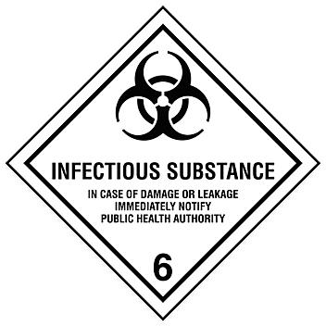
Fig. 1. Infectious Substance label for the transport of Category A.
iv) UN specification marking for P620 packaging (printed on the box).
v) Orientation label, Cargo only label, if required (depending on the Net Weight [kg] of the infectious substance in a P620 box).
The exact details can be found in P620 Packing Instruction.
For air transport:
i) The primary receptacle or secondary packaging must be capable of withstanding, without leakage, an internal pressure of 95 kPa. The primary receptacle or secondary packaging must also be capable of withstanding temperatures in the range of –40°C to +55°C;
ii) For liquids: the net quantity of infectious substances per one P620 box shall not exceed 50 ml for transport in cargo space of a passenger aircraft; and must not contain more than 4 litres (contain multiple primary receptacles totalling more than 4 litres) for transport on a cargo only aircraft;
iii) For solids: the net quantity of infectious substances per one P620 box shall not exceed 50 g for transport in cargo space of a passenger aircraft, and must not contain more than 4 kg (even if containing multiple primary receptacles totalling more than 4 kg) for transport on a cargo only aircraft. This quantity limit doesn’t apply for animal parts, organs and whole carcasses.
iv) The three triple packaging principle has to be adopted accordingly using appropriate packaging systems;
v) The entire package must have been tested and complies with Packing Instruction P620.
For further information on marking and labelling of the Category A shipment package, see P620 Packing Instruction for UN Nos 2814 and 2900⁶

3. Category B
Category B must be transported in a packaging that complies with the requirements of packing instruction P650. The approval of the box by the government is not required, thus UN specification marking is not required.
Marking is as follows:
i) Packages should be clearly labelled with the delivery address and sender’s details to guarantee safe delivery in time at the correct destination.
ii) Label with the proper shipping name in letters at least 6 mm high: “BIOLOGICAL SUBSTANCE, CATEGORY B” (Figure 2)
iii) In addition to the proper shipping name, the mark shown below (UN3373 in diamond) is used for shipments of Category B substances. The UN3373 mark must always be visible on the outer packaging.
6-mm minimum text height
2-mm minimum rule width
6-mm minimum text height
UN3373
50-mm minimum
BIOLOGICAL SUBSTANCE,
CATEGORY B
Fig. 2. UN3373 mark for the transport of Category B substances.
Additional requirements do apply as for category A for international shipment and air transport. One of the main differences between P650 and P620 is the reduced drop-test to 1.2 metres (4 feet).
For air transport:
i) The primary receptacle or secondary packaging must be capable of withstanding, without leakage, an internal pressure of 95 kPa. The primary receptacle or secondary packaging must also be capable of withstanding temperatures in the range of –40°C to +55°C;
ii) For liquids: no primary receptacle shall exceed 1 litre and the outer packaging must not contain more than 4 litres (contain multiple primary receptacles totalling more than 4 litres);
iii) For solids: the outer packaging must not contain more than 4 kg. This restriction doesn’t apply for animal parts, organs and whole carcasses.
The exact details can be found in P650 Packing Instruction for UN No. 3373.
4. Exempt specimens
Biological materials for which there is a minimal likelihood that pathogens are present are not subject to regulation if the specimen is carried in a packaging which will prevent any leakage and which is marked with the words “Exempt animal specimens”, as appropriate. The triple packaging system must still be applied.
5. Biological materials not subject to Dangerous Goods Regulations
This exemption refers to biological materials that do not contain infectious substances and are therefore not subject to dangerous goods regulations (such as class 6.2) and any packaging requirements, unless they meet the criteria for inclusion in another class (such as class 9).
Note: There may be specific regulations in place in some countries for the shipment, export or import of nucleic acids.
6. Overpack
“Overpack” is the term used when one or more packages are combined to form one unit and sent to the same destination by a single shipper. When refrigerants are used to protect contents, the overpacks may comprise insulated vessels or flasks. Whenever an overpack is used, the required marks and labels shown on the outer packaging must be repeated on the outermost layer of the overpack, except for the UN specification marking on P620. This requirement applies to all infectious substances including Categories A and B. Overpacks are also required to be marked with the word “overpack”.
Combining different categories of infectious substance in a same overpack is permissible however in this case outer labelling should indicate the highest category included in the package.
7. Cold chain transportation
7.1. Cold chain requirements
Most biological materials require a cold chain to maintain their integrity. Vaccines can be especially sensitive to temperature fluctuations and must always be transported within their safe temperature range to maintain potency and efficacy.
i) Confirm the safe temperature range for transportation of the material. For transportation of vaccines, follow the manufacturer’s instructions.
ii) Package the material in accordance with its classification, including appropriate temperature monitoring equipment for transportation of vaccines.
iii) Use the refrigerant that will maintain the correct temperature range during transportation.
iv) Label the outer packaging with the recommended transportation temperature range to ensure correct handling during shipping and transfers.
7.2. Refrigerants
Refrigerants may be used to stabilise specimens biological materials during transport.
Ice, ice packs or dry ice shall be placed outside the secondary receptacle. Wet ice shall be placed in a leak-proof container; the outer packaging or overpack shall also be leak-proof.
Dry ice (solid carbon dioxide) must not be placed inside the primary or secondary receptacle because of the risk of explosion. A specially designed insulated packaging may be used to contain dry ice, typically a polystyrene or waxed-treated cardboard box to prevent leakage and maintain temperature. The packaging must permit the release of carbon dioxide gas if dry ice is used and the package (the outer packaging or the overpack) shall be marked “UN 1845” and “Carbon dioxide, solid as coolant” or “Dry ice as coolant” and the weight of the dry ice in Kilograms should also be indicated on the labelling. The package must also bear the Class 9 – Miscellaneous hazard label.
The secondary receptacle shall be secured within the outer package to maintain the original orientation of the inner packages after the refrigerant has melted or dissipated.
If liquid nitrogen is used as a refrigerant, additional requirements have to be followed according to the relevant regulations for dangerous goods (Division 2.2, UN 1977). Information on Dry Shipper is available in p19 of WHO Guidance on regulations for the transport of infectious substances 2023–2024.
D. Additional ConsiderationS
In addition to the transport regulations described above, other international agreements might be applicable.
1. CITES
The Convention on International Trade in Endangered Species of Wild Fauna and Flora (CITES) is an international agreement between governments with the aim to ensure that international trade in specimens of wild animals and plants does not threaten their survival. The Convention is in effect in 183 Parties (including one economic integration organisation, the European Union).
Some specimens to be transported from one country to another may be derived from species covered by CITES (roughly 5,600 animal species and 30,000 plant species). Depending on the classification of the species in one of the three Appendices of the Convention and the movement involved, a CITES export permit, both an export and import permit, or re-export certificates may be required. The appropriate documents must be obtained from National CITES Management Authorities. Simplified procedures for the issuance of permits and certificates exist to facilitate and expedite trade in biological specimens from CITES-listed species.
There may be some variation from one country to another in their CITES trade requirements (some countries take stricter domestic measures and some countries have added additional species requirements for permits in addition to the CITES lists), therefore It is always advisable to check the national legislation that applies.
Further information on CITES: https://cites.org
2. Nagoya protocol and access and benefit-sharing
“Fair and equitable sharing of benefits arising from the utilisation of genetic resources” (Access and Benefit Sharing, or ABS) is one of the three objectives of the Convention on Biodiveristy (CBD). The CBD confirms that States have sovereign rights over their genetic resources, including animals, plants, fungi and microorganisms. Consequently, States may choose to regulate access to these, requiring researchers both within and outside their borders to seek permission. Permission (Prior Informed Consent or PIC) will be the responsibility of the State and maybe other stakeholders, and the conditions for sharing benefits (Mutually Agreed Terms or MAT) may be agreed with a range of actors, including laboratories.
In 2014 the Nagoya Protocol on Access and Benefit Sharing (NP) was agreed by the Parties of the CBD. Nagoya Protocol requirements have been implemented in a large number of countries. This obliges the Parties to take compliance measures and monitor researchers and others utilising genetic resources (accessed from other Parties) within their jurisdiction. Biological material containing genetic resources as defined under the CBD may be subject to national Access and Benefit-Sharing (ABS) legislation in both the country where it is sourced and the country where it is sent. This may include compliance with the NP if both countries are Party to the NP. To discover whether this is the case, consult the ABS Clearing House (https://absch.cbd.int/), and ask the National Focal Point of both countries (contact details on ABS Clearing House). If the source country has ABS legislation it may be necessary to seek a permit (Prior Informed Consent and Mutually Agreed Terms) prior to international transport of the material.
Benefits may be monetary or non-monetary. “Utilisation of genetic resources” is defined by the CBD as “means to conduct research and development of the genetic and/or biochemical composition of genetic resources, including through the application of biotechnology as defined in Article 2 of the Convention”. Consequently, many activities carried out by WOAH Members and their constituents may be classified as ABS.
Compliance will require researchers to produce documentary evidence that genetic resources were accessed with appropriate PIC and MAT, and declaring the type of utilisation being undertaken. This information will be transmitted to the provider country to check if the information accords with their records. There is no exemption for organisms of veterinary importance from ABS provisions in the NP, but countries where they are being accessed may choose to make this distinction and exemption.
Article 8 of the Nagoya Protocol states “In the development and implementation of its access and benefit-sharing legislation or regulatory requirements, each Party shall: … (b) Pay due regard to cases of present or imminent emergencies that threaten or damage human, animal or plant health, as determined nationally or internationally. Parties may take into consideration the need for expeditious access to genetic resources and expeditious fair and equitable sharing of benefits arising out of the use of such genetic resources, including access to affordable treatments by those in need, especially in developing countries;”. However, this is not required and countries may choose to take no action. In addition, there is a 90-day grace period allowed to complete required documents after transport of the biological material.
If the research or diagnostic work on biological material of veterinary concern is considered ‘utilisation’ by the country (Party) in which it takes place the researcher will be required to provide information, including:
i) The Internationally Recognised Certificate of Compliance (number) from the ABS Clearing House, if available; or
a) ABS Permit reference
b) Evidence of Prior Informed Consent
c) Evidence of Mutually Agreed Terms
d) The entity to whom PIC and MAT was granted
ii) The Provider Country
iii) Date and place of access
iv) Description of the Genetic Resources
This information should be included in the documents with the transported biological material.
Although this documentation is only required if both providing country and recipient country are Party to the Nagoya Protocol the provider may have Access and Benefit-Sharing legislation even if not a Party. This should be respected and any documentation required, including permits, Prior Informed Consent and Mutually Agreed Terms, acquired and dispatched with the material.
Further information can be found on:
i) The ABS Clearing House – https://absch.cbd.int/
ii) The CBD Website – https://www.cbd.int/abs/default.shtml
E. REFERENCES and FURTHER READING
WHO Guidance on regulations for the transport of infectious substances 2023–2024: applicable as of 1 October 2023 covering transport regulations on national and international and air transport by different means:
https://iris.who.int/handle/10665/254788
Swiss Expert Committee on Biosafety on Transport of biological substances; practical explanation on how to transport biological substances according to the specific dangerous goods transport regulations:
https://www.efbs.admin.ch/index.php?id=462&L=3
IATA: http://www.iata.org/whatwedo/cargo/dgr/Documents/infectious-substance-classification-DGR56-en.pdf

f. Additional information on the United Nations System for the Transport of Dangerous Goods
The United Nations dangerous goods web site provides comprehensive detail concerning the United Nations Recommendations on the Transport of Dangerous Goods. It also provides links to the modal agencies:
http://www.unece.org/trans/danger/danger.html
The site below provides the full text of the United Nations Recommendations on the Transport of Dangerous Goods – Model Regulations, which can be downloaded in PDF format. Readers wishing to see the text relating to the transport of infectious substances should download Part 2, Part 4 and Part 5 of the Recommendations:
http://www.unece.org/trans/danger/publi/unrec/rev20/20files_e.html
The site below provides the full text of the European Agreement concerning the International Carriage of Dangerous Goods by Road (ADR) of 2017, which entered into force on 1 January 2017, which can be downloaded in PDF format. Readers wishing to study the text relating to the transport of infectious substances should download Part 2 (2.2.62), Part 4 (search P620, P650) and Part 5:
http://www.unece.org/trans/danger/publi/adr/adr2017/17contentse0.html and http://www.unece.org/trans/danger/publi/adn/adn2017/17files_e0.html
Contracting parties to the various conventions for the transport of dangerous goods can be found on a number of web sites:
Air ICAO: http://www.icao.int/Pages/default.aspx and https://www.icao.int/safety/DangerousGoods/Pages/StateVariationPage.aspx
IATA: http://www.iata.org/whatwedo/cargo/dgr/Documents/infectious-substance-classification-DGR56-en.pdf
Rail RID (Intergovernmental Organisation for International Carriage by Rail): http://www.otif.org/. RID is primarily for the countries of Europe, North Africa and the Middle East. There are a number of countries (mainly Eastern Europe and Asia that apply RID through the Organization for Cooperation of Railways (OSJD); details of RID membership can be found at http://www.otif.org/en
Road ADR: https://unece.org/about-adr (lists competent authorities)
Sea IMO (International Maritime Organization): http://www.imo.org
Post UPU (Universal Postal Union): http://www.upu.int/
NB: First adopted in 1992 as Sampling methods.
Most recent updates adopted in 2025.

appendix 1.1.3.1.
Definitions
The following definitions are for the purposes of this chapter only. For general definitions please see the Glossary.
• Biological products
Biological products are those products derived from living organisms which are manufactured and distributed in accordance with the requirements of appropriate national authorities, which may have special licensing requirements, and are used either for prevention, treatment, or diagnosis of disease in humans or animals, or for development, experimental or investigational purposes related thereto. They include, but are not limited to, finished or unfinished products such as vaccines.
• Cultures
Cultures are the result of a process by which pathogens are intentionally propagated. This definition does not include human or animal patient specimens as defined below.
• Infectious substances
For the purposes of transport, infectious substances are defined as substances which are known or are reasonably expected to contain pathogens. Pathogens are defined as microorganisms (including bacteria, viruses, parasites, fungi) and other agents such as prions, which can cause disease in humans or animals. Infectious substances are further classified according to risk into two categories.
• Genetically modified microorganisms (GMMOs) and organisms (GMOs)
Genetically modified microorganisms not meeting the definition of infectious substance are classified in Class 9 (Miscellaneous dangerous substances and articles, including environmentally hazardous substances). GMMOs and GMOs are not subject to dangerous goods regulations when authorised for use by the competent authorities of the countries of origin, transit and destination. Genetically modified live animals shall be transported under terms and conditions of the competent authorities of the countries of origin and destination. DNA, RNA or plasmids are not considered as GMMO and not subject to dangerous goods regulations.
• Medical or clinical wastes
Medical or clinical wastes are wastes derived from the veterinary treatment of animals, the medical treatment of humans or from bio-research.
• Patient specimens
Patient specimens are those, collected directly from humans or animals, including, but not limited to, excreta, secreta, blood and its components, tissue and tissue fluid swabs, and body parts being transported for purposes such as research, diagnosis, investigational activities, disease treatment and prevention.
*
* *

appendix 1.1.3.2.
Example of the triple packaging system (IATA recommendations) for the packing and labelling of different types of biological materials

Fig. 3. Example of triple packaging system for the packaging and labelling of Category A,
UN2814 and UN2900 infectious substances
(Figure kindly provided by IATA, Montreal, Canada).
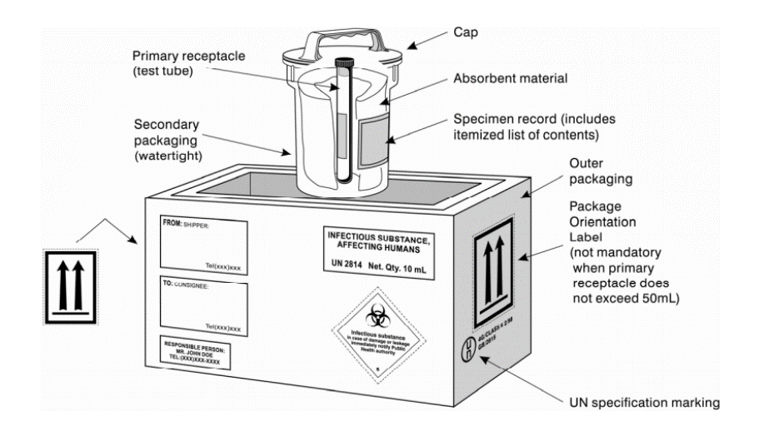
Fig. 4. Example of the triple packaging system for the packing and labelling of Category B, UN3373 infectious substances (Figure kindly provided by IATA, Montreal, Canada).
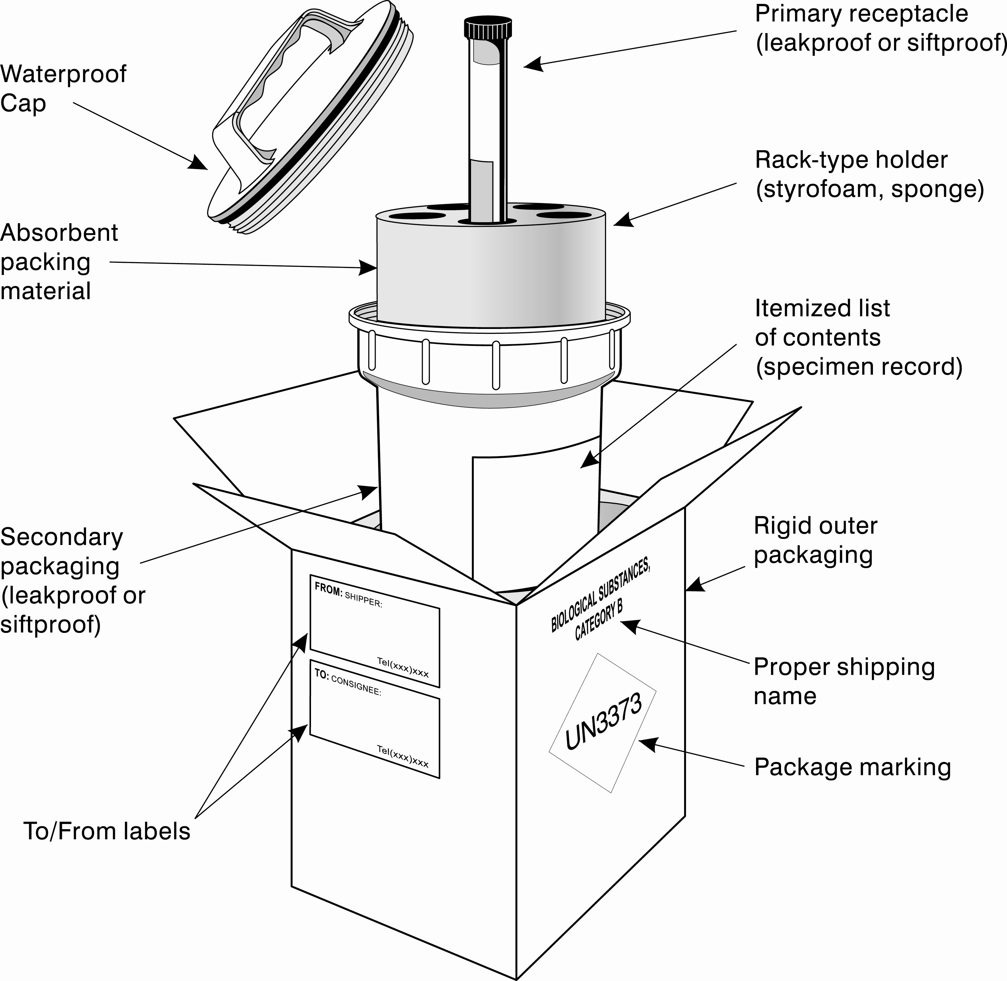
Fig. 5. Example of the triple packaging system for the packing and labelling of Category B, UN3373 infectious substances with non-rigid leakproof secondary packaging
(Figure kindly provided by IATA, Montreal, Canada).
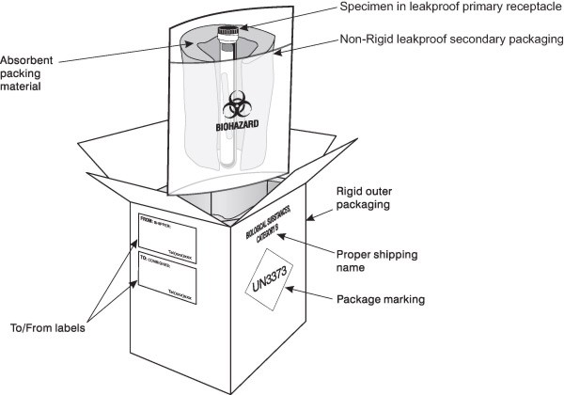
Fig. 6. Example of the triple packaging system for the packing and labelling of Exempt specimen
(Figure kindly provided by IATA, Montreal, Canada).
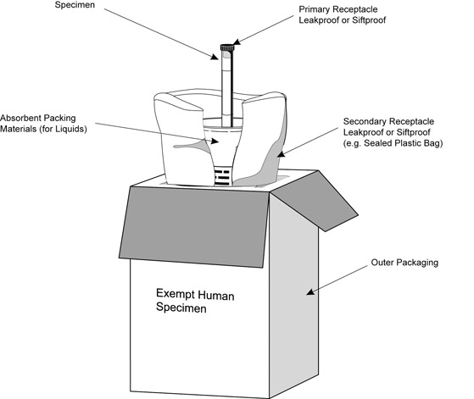

appendix 1.1.3.3.
Material transfer agreement
MATERIAL TRANSFER AGREEMENT
________________
BETWEEN
PROVIDER
Organisation:
Address:
Country:
PROVIDER SCIENTIST
Title and name:
Organisation:
Address:
AND
RECIPIENT
Organisation:
Address:
Country:
RECIPIENT SCIENTIST
Title and name:
Organisation:
Address:
________________
ORIGINAL MATERIAL
Description of the material being transferred
SHIPPING ADDRESS
Title and name:
Address:
I. OBJECTIVE AND PURPOSE
[Insert a short statement about the objectives and intended purpose of the agreement and background to the parties to the agreement.]
II. DEFINITIONS
Provider
Organisation providing the original material. The name and address of this party will be specified in the first page of this MTA.
Provider scientist
The name and address of this party will be specified in an implementing letter.
Recipient
Organisation receiving the original material. The name and address of this party will be specified in an implementing letter.
Recipient scientist
The name and address of this party will be specified in an implementing letter.
Original material
The description of the material being transferred will be specified in an implementing letter.
Material
Original material, progeny, and unmodified derivatives. The material shall not include: (a) modifications, or (b) other substances created by the recipient through the use of the material which are not modifications, progeny, or unmodified derivatives.
Progeny
Unmodified descendant from the material, such as virus from virus, cell from cell, or organism from organism.
Unmodified derivatives
Substances created by the recipient which constitute an unmodified functional subunit or product expressed by the original material. Some examples include: subclones of unmodified cell lines, purified or fractionated subsets of the original material, proteins expressed by DNA/RNA supplied by the provider, or monoclonal antibodies secreted by a hybridoma cell line.
Modifications
Substances created by the recipient which contain/incorporate the material.
Commercial purposes
The sale, lease, license, or other transfer of the material or modifications to a for-profit organisation. Commercial purposes shall also include uses of the material or modifications by any organisation, including recipient, to perform contract research, to screen compound libraries, to produce or manufacture products for general sale, or to conduct research activities that result in any sale, lease, license, or transfer of the material or modifications to a for-profit organisation. However, industrially sponsored academic research shall not be considered a use of the material or modifications for commercial purposes per se, unless any of the above conditions of this definition are met.
Non-profit organisation(s)
A university or other institution of higher education or an organisation exempt from taxation or any nonprofit scientific or educational organisation qualified under a state nonprofit organisation statute. As used herein, the term also includes government agencies.
Agreement
Material Transfer Agreement (MTA)
III. TERMS AND CONDITIONS OF THIS AGREEMENT
Ownership
The provider retains ownership of the material, including any material contained or incorporated in modifications.
The recipient retains ownership of:
(a) modifications (except that, the provider retains ownership rights to the material included therein);
(b) those substances created through the use of the material or modifications, but which are not progeny, unmodified derivatives or modifications (i.e., do not contain the original material, progeny, unmodified derivatives). If either 2 (a) or 2 (b) results from the collaborative efforts of the provider and the recipient, joint ownership may be negotiated.
Non-commercial use
The recipient and the recipient scientist agree that the material is to be used solely for either teaching, non-commercial research or academic research purposes. In this Agreement, non-commercial research purpose and academic research purpose mean that the material cannot be used for commercial purposes, and the recipient may not exploit commercially the results, inventions, discoveries or know-how which incorporates the materials for its own benefit nor for a third party, without the consent of the provider.
Ownership of the results, inventions, discoveries or know-how generated by the recipient using the material shall rest with the recipient. Nevertheless, any results, inventions, discoveries or know-how which contain or incorporate the material, generated by the recipient using the material (“modifications”) shall be jointly owned by the provider and the recipient. However, both the provider and the recipient agree that should the recipient having completed work under this MTA wish to use the material or modifications for commercial purposes it will be necessary for the recipient to negotiate the terms of a license Agreement with the provider, No right are given, implied or intended by this Agreement or the material transfer other than those explicitly stated in this Agreement.
Distribution to third parties
This material should be considered a property of the provider. The recipient therefore agrees to retain control over this material, and further agrees not to transfer the material to third parties or to personnel of the recipient not working under the supervision of the recipient scientist. The recipient agrees to refer to the provider any request for the material from anyone other than those persons working under the recipient scientist’s direct supervision. The provider reserves the right to distribute the material to others and to use it for its own purposes.
The recipient shall have the right, without restrictions, to distribute substances created by the recipient through the use of the original material only if those substances are not progeny, unmodified derivatives, or modifications.
Under a separate agreement at least as protective of the provider’s rights, the recipient may distribute modifications to non-profit organisation(s) for non-commercial research purposes and academic research purposes only, subject to prior written notice to the provider.
Confidentiality
The recipient agrees to treat the materials as it would treat its own confidential and proprietary information and at least no less than a reasonable degree of care, and to take all reasonable precautions to prevent unauthorised disclosure to any third party of the material which it receives hereunder. The provider agrees to keep confidential that the recipient is using the material.
Publications
This Agreement shall not be interpreted to prevent or delay publication of research findings resulting from the use of the material or the modifications. The recipient scientist agrees to provide appropriate acknowledgement of the source of the material in all publications.
Material use liability
The material is provided as a service to the research community at large. It is provided without warranty of merchantability or fitness for a particular purpose or any other warranty, express or implied. No indemnification for any damages is intended or provided under this Agreement. Each party should accept liability for their own actions. The parties make no express or implied warranty as to any matter whatsoever, including the conditions of the research or any invention or product, whether tangible or intangible, made, or developed under this Agreement, or the ownership, merchantability, or fitness for a particular purpose of the research or any invention or product. The parties further make no warranty that the use of any invention or other intellectual property or product contributed, made or developed under this Agreement will not infringe any patent or other intellectual property right. In no event, will any party be liable to any other party for compensatory, punitive, exemplary or consequential damages.
Misuse, dual use and biosafety
The recipient accepts full responsibility for the safety of the research and warrants that the research will be performed in accordance with all local or national laws, rules and regulations. In particular, this material will only be used for research purposes by the recipient in its laboratory under suitable containment conditions.
Under the terms of this Agreement, the material may not be used in human beings.
Termination of the Agreement
The term of this Agreement is 2 years as of the effective date of termination, unless an extension is mutually agreed by the provider and the recipient. At the end of this term, the Agreement shall automatically terminate. Upon the effective date of termination, or if requested, the deferred effective date of termination, the recipient will discontinue its use of the material and will, upon direction of the provider, return or destroy any remaining material. The cost of return or destruction will be taken by the recipient.
Dispute
Any dispute arising under this Agreement instituted against the recipient by the provider shall be brought in the court of the recipient’s country of domicile. Any claims and proceedings against the provider by the recipient shall be brought in the courts of the provider’s country of domicile.
Modification of the Agreement and signatures
This agreement may not be modified, in whole or in part, except by the written consent of both parties. If any provision of this Agreement may be signed in counterpart, and by the parties hereto or separate counterparts, each of which shall be deemed an original.
This Agreement is effective when signed by all parties. The parties executing it certify that their respective organisations have accepted the terms of this Agreement, and further agree to be bound by the terms, for the transfer specified above.
Recipient responsibility
The Recipient undertakes to use the Material in full compliance with any national and international applicable law, including any disposition and guidelines regarding health and scientific research. In particular, the Material having intrinsic health risk shall be handled in full respect of the specific law and in compliance with all the necessary precautions.
The Recipient represents that within its laboratories:
- Access to the Material, Progeny and Modification will be restricted to personnel capable and qualified to safely handle those substances, using appropriate containment;
- Recipient shall use the utmost precaution to minimise any risk of harm to persons and property and to safeguard them from theft or misuse.
The Recipient also acknowledges that in no event the Material applies directly or indirectly to humans.
The Recipient assumes all liability for any and all third party damages and claims arising out of or relating to this Agreement, including the receipt, use, handling, storage, conservation of the Material. To the extent permitted by applicable law, the Recipient agrees to indemnify, defend and hold harmless the provider against all third party claims, losses, expenses and damages, including reasonable attorney’s fees.
The provider shall have no liability towards the Recipient or its employees in the event that the Material and/or Derivatives infringe any intellectual property rights of third parties. The provider makes no warranties for the absence of any third party industrial property rights on the Material.

IV. PAGE OF SIGNATURES
AUTHORISED SIGNATURE OF THE PROVIDER SCIENTIST
Signature:
Title and print name:
Date:
AUTHORISED SIGNATURE OF THE RECIPIENT SCIENTIST
Signature:
Title and print name:
Date:

appendix 1.1.3.4.
Decision trees for the transport requirements of biological materials
Decision Tree 1:
Transport of Biological Materials

Within one country
Across borders

Go to decision Tree 2
Check import, export and transit requirements

Permits or certificates needed
No permits or certificates needed

Go to decision Tree 2

GMO
CITES
(see decision Tree 3)
Access & Benefit-Sharing (including Nagoya)
Infectious substances
Animal products and animal
by-products
Other (dual use, biothreat, etc.)
Follow appropriate processes when required by the importing/ exporting/ transit country, competent authority relevant for the categories intended for transport
After satisfying the requirements for permits or certificates for exportation and making sure that the recipient has acquired the necessary permits or certificates for importation go to the decision Tree 2
Import/
export regulations

Decision Tree 2
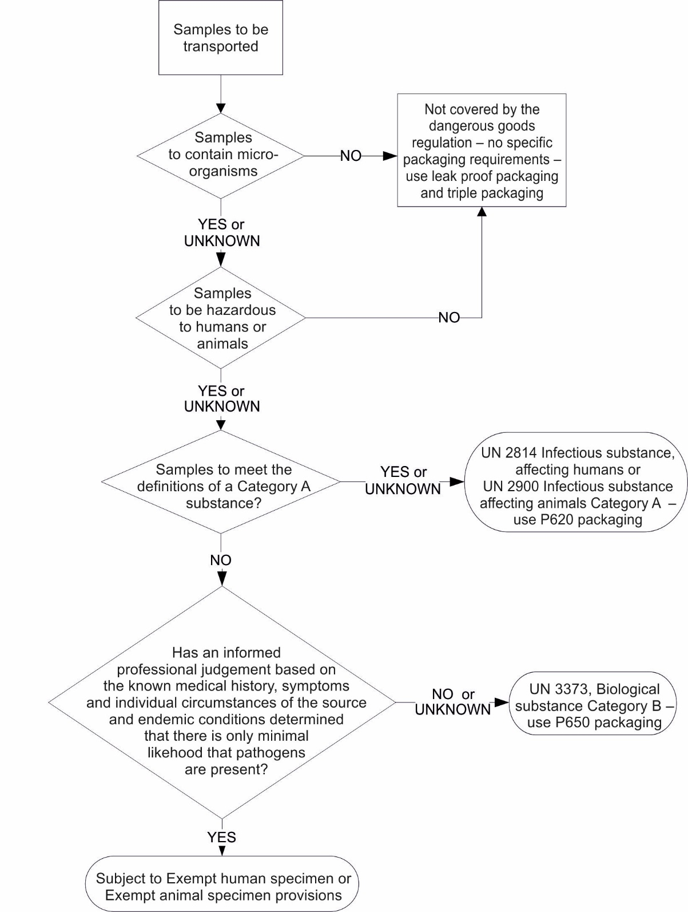

Decision Tree 3

http://www.unece.org/trans/danger/publi/unrec/rev13/13nature_e.html; http://www.unece.org/trans/danger/publi/unrec/rev20/20files_e.html http://www.unece.org/ ; https://unece.org/transport/dangerous-goods/un-model-regulations-rev-23
Dangerous goods are assigned UN numbers and proper shipping names according to their hazard classification and condition under the Dangerous Goods Regulations. See the Dangerous Goods List at pages 191–304 of the UN Model Regulations http://www.unece.org/fileadmin/DAM/trans/danger/publi/unrec/rev20/Rev20e_Vol1.pdf
Dangerous goods are assigned UN numbers and proper shipping names according to their hazard classification and condition under the Dangerous Goods Regulations. See the Dangerous Goods List at pages 191–304 of the UN Model Regulations http://www.unece.org/fileadmin/DAM/trans/danger/publi/unrec/rev20/Rev20e_Vol1.pdf
For surface transport (ADR) nevertheless, when the cultures are intended for diagnostic or clinical purposes, they may be classified as infectious substances of Category B.
Subject to prior approval by the FAO-WOAH rinderpest secretariat
Page 81 at: http://www.unece.org/fileadmin/DAM/trans/danger/publi/unrec/rev20/Rev20e_Vol2.pdf
Page 82 at: http://www.unece.org/fileadmin/DAM/trans/danger/publi/unrec/rev20/Rev20e_Vol2.pdf
https://iris.who.int/bitstream/handle/10665/376214/9789240089525-eng.pdf?sequence=1

