

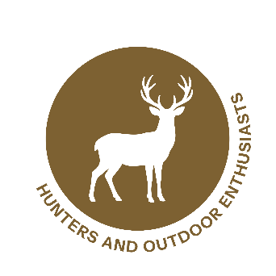
Wildlife Partner Toolkit
Example Social Media Posts

Post 1
🚨**Protect Our Wildlife!**🚨
Are you working with wildlife or in conservation? Here are some tips to prevent the spread of the New World screwworm 🪰:
- Regularly inspect 🔍animals for wounds and signs of infection.
- Report any suspicious cases (Call 📱 USDA Wildlife Services: 866-4USDA-WS, or local wildlife authorities). Your quick reporting helps to get sterile fly releases in your area and additional resources and support.
- Educate others in your community about the risks and prevention strategies.
Let's work together to combat this threat! 🛡️🌿 More info: screwworm.gov [or insert link] #WildlifeConservation #Prevention #ProtectNature
Post 2
🔍**Attention Stakeholders in Wildlife Management!**🔍
The New World screwworm 🪰 poses a risk to our wildlife populations. Collaborative efforts are essential in monitoring, reporting, and managing this threat. Engage with local wildlife agencies and conservation groups to stay informed and active in prevention initiatives. Your participation is vital. Let's act now! 🌍 More info: screwworm.gov [or insert link] #StakeholderEngagement #WildlifeManagement #ActNow
Post 3
🤝**Conservation Starts With Us!**🤝
Whether you're a conservationist, biologist, or wildlife enthusiast, your role in protecting animals from the New World screwworm 🪰 is crucial. Join local workshops and training sessions to learn more about effective detection and response strategies. Together, we can make a difference. 🌿❤️ More info: screwworm.gov [or insert link] #JoinTheEffort #ScrewwormPrevention #WildlifeHeroes

Post 4
🌿 What You Can Do To Help! 🌿If you work in or around wildlife habitats, here are some steps you can take to combat New World screwworm:
- Inspect: Regularly check animals for any signs of infestation.
- Report: Notify authorities immediately if you suspect a screwworm case (Call 📱 USDA Wildlife Services: 866-4USDA-WS, or local wildlife authorities).
- Educate: Share information with peers to raise awareness. Learn more 👉 screwworm.gov.
🚨 Reminder: Early detection and prompt action are key to preventing the spread. Let’s protect our wildlife together! More info: screwworm.gov [or insert link]. #ActionForWildlife #StopScrewworm
Post 5
Wildlife rehabilitation centers play a key role in detecting unusual wildlife 🦝🦌🦊🦉 health issues. Please ensure staff and volunteers know the signs of New World screwworm 🪰 and how to report possible cases promptly 📋📸🧭. Call USDA Wildlife Services: 866-4USDA-WS, or local wildlife authorities. More info: Screwworm.gov [or insert link]. Link to: https://www.aphis.usda.gov/sites/default/files/nws-pest-card.pdf
Post 6
🛡️ Prevent and Protect! 🛡️
Preventing New World screwworm infestations is key. Keep a close eye on injured wildlife and ensure prompt treatment of open wounds. Regular check-ups and maintaining clean environments can reduce risks. Let's work together to safeguard our wildlife! More info: screwworm.gov [or insert link]. Link to: https://www.aphis.usda.gov/sites/default/files/nws-pest-card.pdf #PreventionIsKey #WildlifeProtection #TeamUp
Post 7
📞 Report Promptly! 📞
If you encounter a suspected case of New World screwworm 🪰, report it without delay to your local wildlife agency or USDA Wildlife Services at 866-4USDA-WS. Your quick response can make a difference in controlling outbreaks and protecting other animals. More info: screwworm.gov [or insert link]. #ReportToProtect #WildlifeFirst #StayVigilant
Post 8
🤝 Together We Can!
Collaboration is crucial in the fight against New World screwworm 🪰. Join forces with fellow wildlife rehabilitators and stakeholders to share knowledge, resources, and support. Together, we can ensure a safer environment for our wildlife. Learn more: screwworm.gov [or insert link]. #StrongerTogether #WildlifeCommunity #CollaborateForConservation
Post 9
Attention Wildlife Researchers!
When conducting field investigations, you are often the first to spot unusual animal behavior or signs of infested wounds in wildlife. Help us identify and contain New World screwworm (NWS) with early detection and quick reporting—both are crucial to halting any potential spread and protecting our natural and agricultural resources. Find out more, including how to report suspicious cases of NWS, at screwworm.gov.
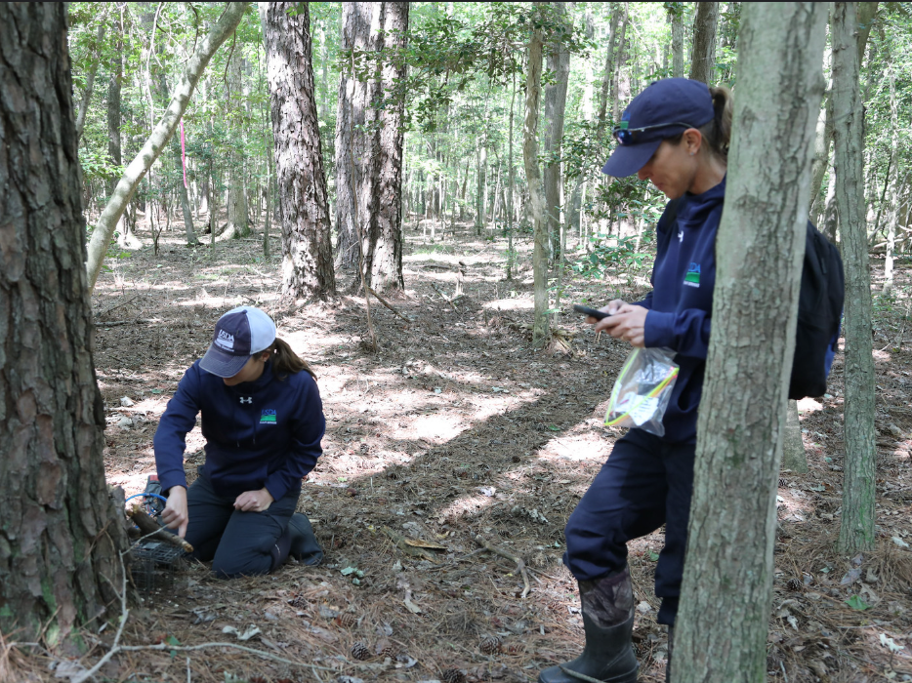
[Link: https://www.flickr.com/photos/usdagov/50517256951/in/album-72157716569863683]

Post 10 (for States/Stakeholders)
Pest control operators, join the front lines against New World screwworm and turn your observations into action. You’re the eyes and ears in wildlife. When you’re out on the job, keep an eye out for odd animal wounds or unusual animal behavior, and don’t wait to report it. By flagging these cases, you help keep our animals safe. Want to know how to report? Visit screwworm.gov and become a hero in pest defense!
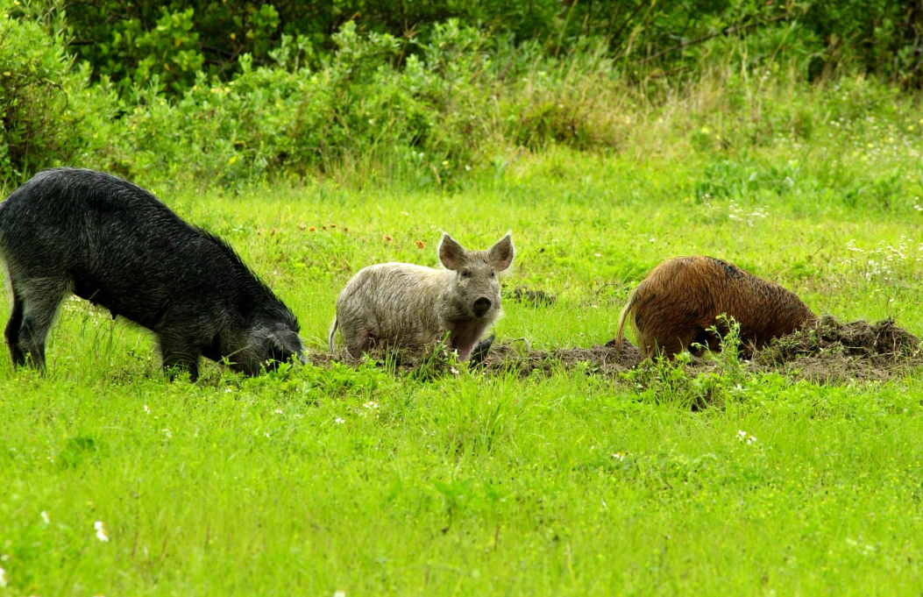
[Link: https://www.flickr.com/photos/usdagov/13592602893/in/album-72157643333780674]

