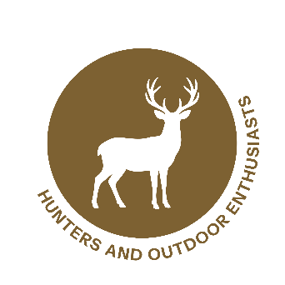

Wildlife Partner Toolkit
Matte Article

Protecting Wildlife Starts With Hunters: Spotting New World Screwworm Early

Before sunrise, along fence lines and deep in the backcountry, hunters are often the first to spot changes in wildlife behavior or health. That vigilance matters. A dangerous pest can quietly devastate animal populations if not detected early. This pest is New World screwworm (NWS).
NWS is a parasitic blowfly (Cochliomyia hominivorax) whose larvae feed on the living tissue of warm‑blooded animals, and it poses a serious threat to both domestic and wild species. Infestations can cause severe tissue damage and high mortality if left untreated.
State and federal agencies are urging hunters to stay alert and report anything unusual. Early detection is one of the strongest tools available to protect wildlife’s health and sustain hunting traditions. Resources and reporting guidance are available at screwworm.gov.
Why It Matters

NWS flies target even the smallest wounds—anything from birthing injuries to tick bites. Once eggs hatch, the larvae begin feeding on living tissue. Wildlife can help NWS spread over long distances as animals move across landscapes and state lines with infested wounds.
Early detection helps hunters and wildlife agencies:
- Stop potential spread.
- Protect game populations: Infested, untreated, animals are unlikely to survive.
- Maintain game quality: Infestations can lead to decreased meat quality, deformities on hides and antlers, stunted growth, and reduced antler development.
- Avoid hunting disruptions: In NWS-affected areas, wildlife agencies may add check stations, increase surveillance, or limit hunting areas. Carcass, meat, and live animal transport could be limited, affecting hunter travel experiences.

How Hunters Can Help

Watch wildlife for signs that could indicate NWS infestation:
- Maggots (larvae) on live or very recently deceased animals
- Larvae in wounds or natural openings (nose, ears, genitalia, navel of newborn animals)
- Wounds with bloody discharge and a foul odor
- Animals showing pain, lethargy, aggression, or withdrawal

Report immediately:
- Contact state officials or USDA Wildlife Services at 866‑4USDA‑WS (866‑487‑3297).
- Record location, date, species, and wound description.
- Take photos or videos if possible.
- Follow state guidelines on the movement of live or dead animals.

Wildlife professionals, conservation groups, and agencies across the country work year‑round to monitor and prepare for potential NWS threats. USDA is conducting extensive surveillance, deploying fly traps, and training field staff. These coordinated efforts depend on timely observations from a community who knows wildlife best like hunters.
For more information about NWS, visit screwworm.gov.
###

