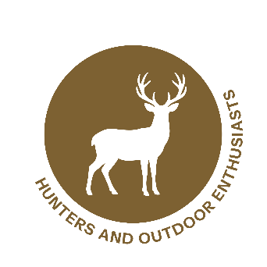

Wildlife Partner Toolkit
Matte Article

Wildlife Surveillance Is Key To Stopping New World Screwworm
Hunters know the land better than anyone. Whether you’re easing through thick brush before daylight, glassing from a ridge, or tracking a buck, you see things others miss. That field awareness makes you a crucial first line of defense against New World screwworm (NWS), a serious pest that threatens wildlife, livestock, pets, and, less commonly, people.
Changing conditions and increased animal movement mean this pest can spread quickly if left unchecked. The adult fly targets even the smallest wounds (from a tick bite to a birthing injury) to lay its eggs. Once the larvae hatch, they feed on the living tissue of warm‑blooded animals. Wildlife with infested wounds that move across properties and state lines can unintentionally carry NWS into new areas.
As a hunter, you’re often the first to notice when an animal looks “off.” Maggots or white egg masses, oozing wounds with a strong odor, or infested navels on newborn animals are all red flags. Any maggots on a live or recently deceased animal should be treated as suspicious and reported immediately.
Why does this matter? Because NWS can devastate wildlife populations. Infestations reduce fawn survival, impact antler growth, and weaken herd health. During high‑stress seasons (for example, the rut or recovery from injuries) animals are even more vulnerable. Your quick action can mean the difference between one contained case and a widespread outbreak.
When you’re in the field or processing harvested game, take a moment to look closely. If something doesn’t look right:
- Record the GPS location, date, species, and what you observed.
- Take photos or videos if safe (save trail cam images if available).
- Avoid moving a potentially infested carcass.
- Report immediately to your local wildlife agency or USDA Wildlife Services at 866‑4USDA‑WS (866‑487‑3297).
If you travel for hunts, stay aware of transport rules. Some states restrict movement of carcasses, meat, hides, and live animals to prevent the spread of pests and diseases like NWS. Checking regulations before crossing state lines helps protect game populations everywhere.
Across the country, wildlife professionals and USDA teams monitor for NWS year‑round, but none of their efforts can replace what hunters see on the ground. Your vigilance helps agencies respond faster and strengthens surveillance across entire landscapes.
Your time outdoors makes you an essential partner in protecting America’s wildlife. By staying alert, recognizing the signs, and reporting quickly, you’re helping safeguard the herds we value and the hunting traditions we pass down. For more information and reporting resources, visit screwworm.gov.
###

