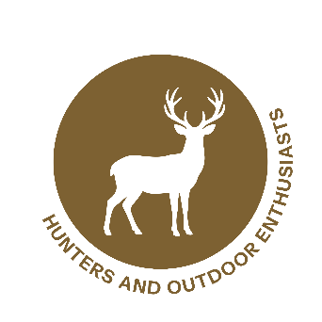

Wildlife Partner Toolkit
Text for Hunting Regulation Booklets, Guides, or Licensing Websites

Use this text in hunting regulation booklets, guides, or licensing websites to help hunters recognize, report, and prevent the spread of New World screwworm (NWS).

Short Version

Hunters play a key role in monitoring wildlife from New World screwworm (NWS), a serious pest whose maggots (larvae) feed on the living tissue of warm-blooded animals. Wildlife can help NWS spread over long distances as animals move across wide areas with infested wounds. Check harvested or live animals for signs of NWS infestation: wounds with maggots, bloody discharge, foul smell, or animals with odd behavior. If you find signs of NWS, document the species, location, and symptoms, then report immediately to local wildlife authorities or the USDA (866-4USDA-WS | screwworm.gov). Avoid moving infested live or recently dead animals and stay up to date on regulations. Early detection is critical for stopping outbreaks and protecting wildlife health.
###

Long Version

New World Screwworm (NWS)

Facts About New World Screwworm
NWS is a parasitic blowfly (Cochliomyia hominivorax) whose larvae feed on living animal tissue.
- Affects warm-blooded wildlife (e.g., deer, rabbits, feral hogs); livestock; pets; and occasionally people.
- Early detection is critical for protecting wildlife health and preventing spread.
- Infestations can lead to severe pain, infection, and death in wildlife—impacting game populations, fawn survival, and overall herd quality.
- Wounded animals (rutting bucks, newborn fawns, injured game) are at higher risk.

Look for any of these signs in wildlife:
- Maggots or larvae in open wounds or natural openings (nose, ears, genitalia, navel of fawns)
- Wounds that do not heal, often with bloody discharge and a strong, foul odor
- Animals showing pain, irritability, or isolating themselves

NWS is not contagious between animals or people. Not all maggots indicate NWS, but any larvae in a living animal should be treated as suspicious and reported immediately.

If You See a Suspicious Animal
- Record helpful details:
  - Species
  - Location (GPS if possible)
  - Photos or videos (if safe to obtain)
  - Description of wounds or behavior
- Report immediately to local wildlife authorities or USDA Wildlife Services:
866-4USDA-WS (866 487 3297). Reporting options also available at screwworm.gov.

Additional Tips:
- Avoid moving wounded or potentially infested wildlife.
- Follow all local and state rules for carcass transport and disposal.

Protecting deer, elk, and other wildlife helps maintain healthy game populations and supports sustainable hunting, while enabling wildlife officials to respond quickly.

For more information and resources, scan the QR code:

[Use the USDA QR code above to link to wildlife-specific resources on screwworm.gov (https://www.aphis.usda.gov/animals/animal-health/livestock-and-poultry-disease/stop-screwworm/wildlife), or feel free to add your own QR code that directs readers to another relevant page or resource.]
###

